Project Report
CSE 598 Design and Analysis of Algorithms

A Survey of Ray Tracing Acceleration Techniques

Yvonne Lu
Computer Science & Engineering Department
Arizona State University
yvonnel@stockwellscientific.com

Min Huang
Computer Science & Engineering Department
Arizona State University
megan.huang@asu.edu

Report Work Percentage
Yvonne Lu – 50%
Min Huang – 50%

Ray Tracer Implementation
Yvonne Lu -100%

Abstract 1
1.0 Introduction of Ray Tracing and Ray Tracing Basics 1
1.1 Recursive Ray Tracing as Illumination Model 2
1.2 Intersections in Recursive Ray Tracing 6
1.3 Shadows in Ray Tracing 8
1.4 Advantages and Disadvantages of Ray Tracers 9
2.0 Basic Ray Tracing Accelerators 10
2.1 Adaptive Depth Control 10
2.2 Bounding Volumes 11
3.0 Basic Ray Tracing Summary and Future Works 15
4.0 Ray Tracing Practical Applications: 16
4.1 Volume Rendering 16
4.2 Generating still images 17
4.3 Movies 17
5.0 Acceleration Technique: Spatial Coherence 18
5.1 Basic Algorithm 19
5.1.1 Octrees 19
5.1.2 Uniform Spatial Subdivision 20
5.1.3 Binary Space Partitioning (BSP) Tree 23
5.2 Algorithm Analysis and Comparison 27
5.2.1 Potential Problems and Solutions 27
5.2.2 Complexity Analysis 31
6.0 Conclusion: 38
6.1 Comparing To a Naïve Ray Tracer: 38
6.2 Comparing To Bounding Volumes and Bounding Volume Trees: 38
6.3 Comparing to Each Other: 39
7.0 Ray Tracer Implementation 40
References 43

A Survey of Ray Tracing Acceleration Techniques

Abstract
The application of ray tracing was initially started in the study of physics. Its traditional uses were to model the propagation behaviors of electromagnetic energy through various media. The capabilities of this technique attracted graphics software developers/programmers. Thereafter, the computer graphics industry took the concept of ray tracing into a whole new direction: uses ray tracing to synthesize and simulate images. Due to its versatility, ray tracing becomes the basic tool for light-object intersection. In fact, ray tracing in computer graphics began as far back as in 1980. It has been extensively researched over the years. Although ray tracing produces clear and almost-real images, it suffers one major drawback – calculation time is long because this technique traces infinite number of thin rays. Many researches have been focused on developing efficient schemes to overcome this disadvantage of tracing infinitesimally ray. This research paper will survey several ray tracing acceleration techniques and compare the performance improvement with a naïve ray tracer. The first section of the paper presents the basic ray tracing principles, its advantages, and disadvantages. Section 2 discusses some basic ray tracing acceleration techniques. Section 3 briefly the discussion on basic ray tracing. Sections 4 and 5 briefly discusses the practical application of ray tracing. Acceleration techniques are discussed in these sections. In this section, we will analyze several efficiency schemes that attempt to reduce the computational cost of ray tracing. The two major approaches illustrated are decrease-and-conquer and divide-and-conquer schemes. Conclusion and sample implementation regarding ray tracing fall into last two sections of the paper.

1.0 Introduction of Ray Tracing and Ray Tracing Basics
The notion of ray tracing began and first used in the study of physics. As light propagates through an environment, its behaviors change when objects intersect the path of propagation. In the study of physics, the aspects of light-object interaction, such as reflection, shadows, and hidden surface removal, are viewed and handled as separate entities. In the computer graphics industry, these aspects were implemented as separate ad hoc algorithms. In fact, it was Whitted [21] who first suggested of integrating reflection, refraction, hidden surface removal, and shadows into one model. Since then, ray tracing is used as a versatile rendering technique that integrates these aspects as one. Thus, it becomes the basic tool for light-object interaction due to this versatility.

Recursive ray tracing is one of simplest rendering techniques. It traces the path of each reflected and refracted (or transmitted) ray through an environment. In term of for each pixel, a ray is traced from a view point through the environment and into the scene. Theoretically, the rays are considered to be infinitely thin and reflection and refraction occur without any spreading. However, this is not possible in reality. Reflections occur with diminished sharpness because surfaces are never smooth. Rays are reflected and refracted and spread at the same time. Despite all these negativities, many of the researches have been devoted to recursive ray tracing because of its impressive image production. Much of the research effort has been focused on computational demands of recursive ray tracing and speedup techniques. In the next subsections, this paper explains how recursive ray tracing is used as an illumination, intersection, and shadow models.

1.1 Recursive Ray Tracing as Illumination Model
One advantage of recursive ray tracing is that its framework can incorporate many aspects of light-object interaction:
- Hidden surface removal
- Shadow computations
- Reflection
- Refraction
- Global specular interaction
In a general sense, recursive ray tracing is a process of creating a tree structure. It generates a tree composed of a node for each object and its children are objects intersecting reflected and refracted rays. It is like a general binary tree where refracted and reflected branches are emanating from each node. When a ray intersects an object, it spawns into two rays: one as reflected ray and another as transmitted or refracted ray. Each of these rays produces two other rays at the next intersection with an object. Figure 1 depicts the result of ray tracing process as a tree. At a given level i, there are maximum 2^{i} rays at that level, assuming both reflection and refraction occurred for each ray. Level 0 is the initial state, and there is one ray, which is the one that is being traced from the viewer into the scene. When Object 1 intersects this ray, ray spawned into two rays; this is level 1. Each of these spawned rays also spawns into two rays when it is intersected. Thus, there are four rays at level 2. Each level is the depth of the level. When depth i = 0, 1, 2, 3, 4, …, the number of rays at depth i is 1, 2, 4, 8, 16, …, respectively. A recursive trace process terminates when a pre-determined recursive depth is reached or when a ray hits nothing and is allocated a background color.
Eye
Object 1
Object 6
Object 5
Object 4
Object 3
Object 2
Object 7
Refracted
Reflected

Figure 1: Ray tracing as a general binary trace tree.

This processing structure induces high computational cost in recursive ray tracing. When tracing, rays are traced backwards, against direction of light propagation, from the view point through each pixel in the image plane and into the scene. Light propagation initiates from the light source, and rays travel from surfaces or penetrate through objects and finally through pixels on an imaginary plane to the viewer. It is extremely difficult to traces rays in the direction of light propagation because an infinite number of ray emanating from the light source. Therefore, a ray tracer traces in the reverse direction of light propagation. The purpose of this reversed direction of tracing is to reduce the number of rays for tracing. Only those rays that pass through the view plane are considered. This is still not enough to reduce the computational cost, as this will explain later.

The initial rays traced from the pixel into the scene actually perform the aspect of hidden surface removal. In a naïve ray tracer, a ray is tested against all objects in the scene for intersection. If there are N objects in the scene and at a give depth level i, the number of intersection tests for depth i is N*2^{i}. Then the total number of intersection tests for a given scene is:
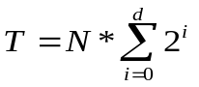 (1)
where: d is the depth of the trace tree
If multiple objects intersect a ray, the object nearest to the ray origin is the selected intersection. Direct illumination corresponds to the last direction traced from the surface to the light source, of course that is traveling against the direction of light propagation. Illumination is affected by several factors. An illumination model determines the measurement of reflection to the viewer as a function of light source direction and strength, location of viewer, surface orientation, and surface properties. Anyhow, the ray tracing tree terminates when either one of the following holds true:
- Encountering a reflection
- A shadow feeler is applied from the surface to light
Thus, at each intersection point, light reflected from a point onto a surface can be modeled as:
I = I_{local} + K_{rg} I_{reflected} + K_{tg} I_{transmitted} (2) [17]
Reflection is a linear combination of three terms. The first term is the local term due to direct illumination. Both K_{rg} and K_{tg} are global reflection and transmit (or refracted) coefficients, respectively. I_{reflected} and I_{transmitted} are intensity functions for a ray reflected or refracted from a surface, respectively. Equation (2) can be rewritten in term of intersection point:
I(P) = I_{local}(P) + K_{rg} I_{reflected}(P_{r}) + K_{tg} I_{transmitted}(P_{t}) (3) [17]
where: P is the intersection of the considered point
P_{r} is the first hit of the reflected ray from P
P_{t} is the first hit of the refracted ray from P
Ray tracing is a recursive process. Thus, Equation (3) can be written in another format:
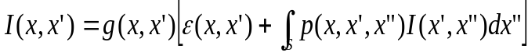 (4) [KAIJ86]
where:
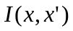 | is the intensity of light passing from point x’ to x
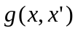 | is the occlusion of surface points by other surface points; this term is 0 when surface is transparent or x’ and x are not mutually visible
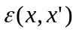 | is the intensity of light emitted from x’ to x
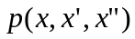 | is intensity of scattered light from x” to x by an intersection point on surface at x’

This is the rendering equation describing light scattering off various types of surfaces. The intensity of a transport light from one surface to another is the sum of the emitted light and the total intensity scattered toward x from all other surfaces. This equation is very similar to (3), such that it is an enclosure for the entire scene, encompasses all objects in the scene, and accounted for the recursive calculations on scattered rays. In [17], a simple recursive coding implementation is presented, which is shown below.

Simple Code to Recursive Ray Tracer

#include “types.h”

int ray_hit(point hit_point,
point reflected_direction,
object *hit_object,
point *transmitted_direction);

void TraceRay(point start_point, point direction, int depth, color *color)
{
point hit_point, reflected_direction, transmitted_direction;
color local_color, reflected_color, transmitted_color;
object hit_object;

if (depth > MAXDEPTH) then
*color = black;
else
{
// Intersect ray with all objects in scene and find any intersection point
// that is closest to the start of ray.
if (ray_hit(start, direction, &hit_object, &hit_point))
{
// Assign local color at intersection point.
shade(hit_object, hit_point, &local_color);

// Calculate direction of reflected and refracted rays.
calculate_reflected(hit_object, hit_point, &reflected_direction);
calculate_refracted(hit_object, hit_point, &transmitted_direction);

// Recursively call TraceRay to trace the paths of reflected and refracted rays.
TraceRay(hit_point, reflected_direction, depth+1, &reflected_color);
TraceRay(hit_point, transmitted_direction, depth+1, &transmitted_color);

// Combine colors according to the properties of hit object’s surface.
Combine(hit_object, local_color, reflected_color, transmitted_color, color);
}
else
*color = BACKGROUND_COLOR;
}
}

1.2 Intersections in Recursive Ray Tracing
A recursive ray tracer follows the path of each ray from a view point into the scene and an intersection test is performed on each ray by checking the ray against every object in the scene. If multiple intersections occur, then the coordinates of the nearest hit along the ray are used for intersection point. Intensity calculation is done at that point. Reflected and refracted rays are spawned and the process is called again recursively. If no object is adopted for intersection checks, ray tracer will spend most of its time testing for intersections. “In [21] Whitted estimated that a recursive ray tracer spends up to 95% of its time testing for intersections” [17]. This imposes a huge computational cost to the process. Two issues must be dealt with when:
- Executing checks for intersections
- Adopting a strategy that guides the order in which to perform intersection checks
Of course, computational expense of each intersection test depends on the complexity of the object representation. One method resolving these intersection issues is using bounding volume with intersection checks. If a ray does not intersect the bounding volume of an object, then the object is ignored from further processing for that particular ray. There are numerous bounding volumes can be used with intersection checking. Naming a few:
- ray-sphere
- ray-polygon
- ray-box
- ray-quadrics
The complexity of intersection checking with bounding volumes increases from ray-sphere to ray-quadrics because of complex computations. Fortunately, intersection calculations are separate from the part of process that traces the ray and calculates pixel intensity.

Spheres are frequently used as bounding volumes because the complexity of an object is temporarily represented by complexity of the sphere. Bounding spheres enclosed complex objects and object is considered only when the ray intersects the bounding sphere. Two advantages of using bounding spheres are: 1) the ease of enclosing object in a sphere and 2) quick intersection check. Spheres are special cases of rays intersecting with quadrics, such as cylinders. For non-spherical objects, additional processing must be specified when a ray intersects the bounding quadric. For polygon surfaces, the intersection point and plane of polygon must be calculated and intersection check must be performed to see if the point in on the interior of the polygon. If the surface consists of bicubic patches, bounding spheres are generated for each patch. If the bounding spheres are pierced by rays, then the patch is further divided, and again, bounding spheres are created for each subpatch. This subdivision process is repeated until one of these conditions holds: 1) no bounding sphere is intersected or 2) the intersected bounding sphere is smaller than predetermined minimum. To ensure that no object is lost for intersection checking, a minimum radius is allowed for bounding spheres. In another word, the bounding sphere of a small object, regardless how small the object, will always be intersected by at least one ray. Spheres have their disadvantages as well. One of the disadvantages is that sphere might not be the suitable structure opt for bounding. If a bounding sphere contains a large void area because it is not optimum for the shape of the object it encloses, then this actually complicates the intersection checks because number of intersection checks must be performed for that area.

Regardless which object definition is used as bounding volume, intersection check follows similar process. The following steps are generally applied when testing for intersection.
- Find if the ray’s origin is outside of the bounding volume.
- Find the closest approach of the ray to the bounding volume’s center.
- If the ray is outside of the bounding volume and points away from the bounding volume, then ray must have missed the bounding volume.
- Otherwise, find the distance from the closest approach to the surface of bounding volume.
- If the value is negative, the ray misses the bounding volume.
- Otherwise, find the ray-bounding volume distance.
- Calculate the intersection coordinates.
- Calculate the normal at the intersection point.

1.3 Shadows in Ray Tracing
Shadows are produced when other objects block the direct illumination on a surface. The intensity of a shadowed area is a function of diffuse emission from nearby surfaces. Thus, shadows are local decrease in the diffuse light reflected from surface due to illumination blockage. The shape and its intensity are two main factors in shadow calculations. These can be easily incorporated in the ray tracing model for diffuse intersection. For each intersection point, it is checked to see if the point is in the shadow or not. This is done by tracing the path of ray from the intersection point to each of the light source. If the intersection point is in the shadow area, then I_{local} from Equation (1) will be decreased by some arbitrary amount. If an object intersects the ray, then the intersection point is indeed in shadow, provided that the object lies between the light source and the point of interest. This is the process used by the “shadow feeler”. Unlike ray-object intersection, shadow feeler-object intersection needs not consider finding the object closest to the ray origin. Like ray-object intersection, shadow calculation adds huge computational overhead to ray tracing by increasing the number of light sources. According to Watt [17], the shadow feeler intersection tests in a naïve ray tracer rapidly predominate as the number of light sources multiplies. Each intersection would now spawn n + 2 rays – one reflected ray, one refracted ray, and n shadow feelers, where n is the number of light sources. Shadow testing can be accelerated via methods like “light buffer” proposed by Haines and Greenberg [23]. Testing time could be reduced as much as 4 to 30 percent[17]. Shadow testing becomes complicated when involving semitransparent objects because they act as color filter, and intensity absorbers. Caustics can occur as well. Thus, one shadow feeler must be used for each color band of interest.

1.4 Advantages and Disadvantages of Ray Tracers
Recursive ray tracing is capable to incorporate all aspects of ray-object intersection into one framework. The tracing of a ray is done against the direction of light propagation; therefore, this technique automatically reduces the number of rays used in intersection testing. Unfortunately, recursive ray tracing possess high computational cost. Ray tracer is impractical in reality because of the time spent in intersection testing. When modeling diffuse interaction in ray tracing method, the number of reflected and refracted rays spawned at an intersection point increased enormously. The method would become impossible for computation. In the next sections, this paper will present some ray tracing accelerators that will resolve some of these issues.

2.0 Basic Ray Tracing Accelerators
In general, ray tracing is basically estimating global illumination by tracing rays from viewer through an imaginary plane and into the scene. For each ray, the closest intersection point to the origin of the ray is determined and illumination (intensity) calculation is done for that intersection point. A ray may then be reflected and refracted depending on the surface property. These spawned rays are recursively traced in the same fashion. This brute force approach for naïve ray tracing performs intersection check for each ray against every object in the scene. As mentioned in the previous section, a ray tracer spends most of its time checking for intersections. This intersection-checking scheme affected the performance of ray tracing. In this section this research paper presents several known acceleration methods to speed up the performance. These methods are categorized into two groups: reduce-and-conquer and divide-and-conquer. Each method has its advantages and disadvantages. The first subsection will explore adaptive depth control. In the second section, this paper will examine how some sophisticated techniques involving bounding volumes are used in intersection checks. The last set of acceleration techniques are focused on spatial coherence.

2.1 Adaptive Depth Control
The main object of adaptive depth control is to reduce the levels in tracing. In a naïve ray tracing, a trace terminates when one of the following condition holds:
- A ray intersects nothing and a background color (intensity) has been assigned.
- A predetermined trace depth is reached.
In the last section, the paper introduced of using a binary tree to depict the spawning of a ray when an object intersects the ray. This abstract tree structure can be used to visualize the depth of tracing. When traversing down the tree, trace depth deepens. For each ray, an intersection check is done for every object. In another word, the height of binary tree grows and the depth of tracing increases. The number of connected rays traced increases as well.
The pruning technique used in adaptive depth control is varying the trace depth according to the nature of region through which the rays travel. Different branches of the tree are pruned to different depths; thus, the overall number of rays traced should be reduced. The number of intersection checks should decrease as well. Will reducing trace depth affect the outcome of the final image? No. Effects of rays deep down the tree have imperceptible effect on the final image and rays are attenuated at each intersection point. Adaptive depth control depends on the properties of the object (i.e. material) with which the rays are intersected. When the ray is reflect at the surface, it is attenuated by a global specular reflection coefficient for the surface. In refraction, a ray’s attenuation determines by the surface’s global specular transmission coefficient. A ray low down in the trace hierarchy makes contribution to the top-level ray, which is attenuated by these coefficients. The contribution of this low-down ray is then attenuated by the product of all global reflection and transmission coefficients above it. When the product falls below the threshold, the trace process can terminate. Therefore, a ray that is examined by as a result of tracing through several intersections contributes imperceptibly to the final image. [17] reported that “for a highly reflective scene with a maximum tree depth of 15, …this method results in an average depth of 1.71…” This is a significant saving in image generation time. The percentage of saving depends on the properties of the objects and their distribution in the scene.

2.2 Bounding Volumes
Bounding volumes are used to improve the time used to perform intersection calculation. In the introduction, the application of bounding volumes is to reduce the depth structure of the trace (ray) tree. This section focuses on how bounding-volumes scheme is useful for pruning a branch of the binary ray tree. The notion behind this scheme is that a simple bounding volume can be used to enclose an object of some-degreed complexity. Instead of intersection test against the object, bounding volume is checked to determine if it has intersected the ray. If an object contains many polygons, bounding volumes can improve the test time because testing against every polygon become unnecessary and one test against the bounding volume is all that’s needed. If the ray does not intersect the bounding volume, then it does not intersect the polygonal object as well. As mentioned before, many shapes can be used as bounding volumes. The most common one is bounding sphere. The suitability of using a particular volume for bounding depends on the shape of the bounded object. The objective is to choose a bounding volume such that most of its area is occupied by the object. If most of the bounding volume is empty and viewing this scenario from a branch level on the ray tree, intersecting ray hitting the bounding volume would miss the object and unnecessary intersection tests would need to be done on the object.

An oriented volume may enclose more of the object, having less empty area, than when it is not oriented. This leads to a brief discussion of slabs. A slab is a type of bounding volume that overcomes the problem of void area but yet still retains the advantages of a hierarchical bounding volume scheme. Pairs of parallel planes are used to create the bounding volume. Slab is the region between a pair of parallel planes. The normal vector that is defined for any one of the parallel-planes set defines the orientation of slab. Each slab is associated with two scalar values, d_{near} and d_{far}. When a ray misses the bounding volume, then d_{near} will be greater than d_{far}. The more slabs used to bound an object, the tighter the fit is for the bound. In Figure 2, the bounding volume is surrounded by three pairs of parallel planes. Each slab has its own d_{near} and d_{far} values. When a ray intersects the bounding volume, it should intersect d_{near} and d_{far} and value of d_{near} should be less than value of d_{far}. If intersection test finds value of d_{near} > value of d_{far}, it is certain to say that the ray has missed the bounding volume and the enclosed object.

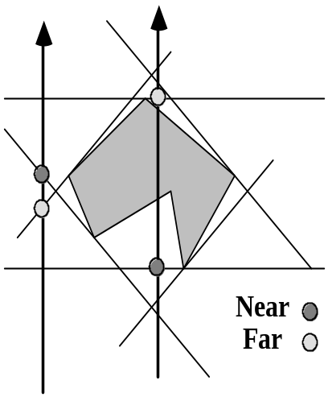
Figure 2: Using slabs as bounding volume and for intersection tests. [24]

The efficiency of a bounding volume is a function of void area, which is the empty area in the bounding volume that is not occupied by the enclosed object:
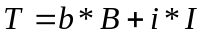 (5)
where:
T is the total cost function
b is the number of times the intersection tests done on the bounding volume
B is the cost of testing bounding volume for intersection
i is the number of time the object is tested for intersection
I is the cost of testing the object for intersection
This is a cost function for an intersection test; it also denotes that void area is a function of object, bounding volume, and ray direction. B represents complexity of bounding volume. As B decreases, i is increased because additional and unnecessary intersection tests are ran. Equation (5) suggests one thing: the use of bounding volume does not reduce the number of intersection check. The usefulness of bounding volume becomes more effective when it is applied in hierarchy structure. Objects in close spatial proximity can be formed as clusters and clusters are enclosed in bounding volumes. A ray tracer descents through a hierarchy of bounding volumes if and only if the intersections occur there. For example, Figure 3 depicts a hierarchy of bounding volumes. The top hierarchy is the entire scene itself. Sub-hierarchies 2 and 3 are bounding volumes enclosing others volumes. Hierarchy 2 enclosed two bounding volumes, which bounding objects A and B. The tree structure represents the hierarchy and enclosed objects in each sub-hierarchy.
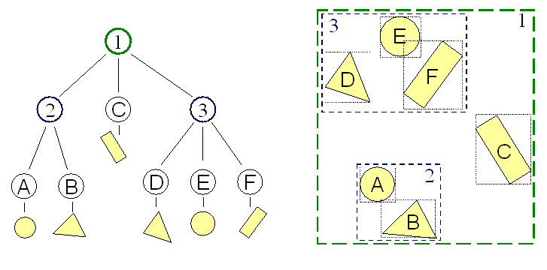
Figure 3: A hierarchy of bounding volumes [24]
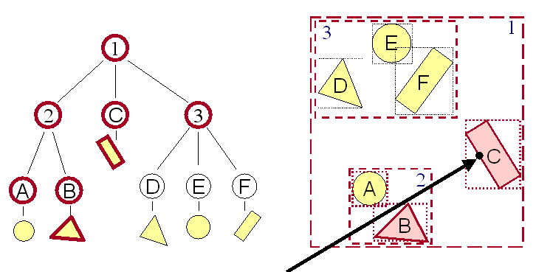
Objects in the same the cluster are testing for intersections when the ray intersects their hierarchical cluster. Figure 4 shows how hierarchy improves intersection testing. Ray R tests against 3 bounding volumes and 2 objects: when testing bounding volume 2, it enters a cluster, tests against 2 more bounding volumes and finally 2 objects, and finds no intersection with object B. The total number of object tests is 2, compared with 6 object tests with naïve ray tracing technique.

Figure 4: Use Hierarchy to accelerate ray intersections [24]
In the figure, the tree on the left depicts the path of tracing. Using bounding-volume hierarchy, intersection-test time becomes logarithmic instead of the number of objects in the scene. A secondary data structure is usually needed to maintain information about the hierarchy. Although it decreases the computational overhead, this method has a high cost because the bounding volumes at low levels may be inefficient. Clusters are created if and only if the objects are closed to each other. The process becomes obviated when clusters are created for objects that are widely separated. [17] lists several properties for a hierarchical scheme:
- Any given subtree should contain objects that are in close proximity.
- The volume of each node should be minimal.
- The sum of volume of all bounding volumes should be minimal
- The tree should be constructed such that the nodes nearer to the root of the tree should be concentrated. The objective is to remove a large subtree from further consideration when pruning a branch of tree at that area. Pruning at a lower subtree would only remove few bounding volumes and objects from further consideration.

3.0 Basic Ray Tracing Summary and Future Works
Image simulation and generation becomes increasingly demanded in many industries, such as in entertainment, film-making, medical fields like radiology, security like face recognition, etc. Ray tracing is a rendering method for simulating and generating images. In naïve or recursive ray tracing, each ray is traced against all objects in the scene, even though it may be far distant from an object. This tracing method is expensive and too much time consumed for tracing a ray through the entire trace tree depth. Adaptive depth control (ADC) technique is used to avoid this type of tracing. ADC utilizes the material properties of the object to determine tree depth for tracing. The reflective and refractive behaviors of a ray depend upon the object’s material property because each material has a pre-defined reflection and refraction coefficients. For a ray intersecting multiple objects, as traversing deep down into the tree, tracing could simply be terminated after some pre-determined depth. Bounding volumes is another technique addressed in this research paper. A bounding volume simplifies the complexity of an enclosed object by representing the object with a simpler volume and the intersection test is done on the volume instead of the object. The suitability of a volume for bounding an object depends on the tightness of the fit. The orientation of the bounding volume does come into play when defining this tightness. When objects or bounding volumes are near each other, they can be clustered and forming a hierarchy of bounding volumes. This hierarchical structure reduces the number of ray-object intersection tests.

Reducing the computational overheads in ray-object intersection tests contribute to the usage of secondary data structure. For example, a hierarchy of bounding volumes uses a secondary data structure to maintain information about the volumes and enclosed objects. This is an overhead added to the memory space and run time. Although this overhead cost is separated from the part of process that traces the ray and calculates pixel intensity, it is affecting the overall performance of ray tracing. Future research direction could point toward the area of integrating database model with ray tracing. When a tracer performs an intersection check at any intersection point, it can then interface with a database to acquire information about that intersection point.

4.0 Ray Tracing Practical Applications:

Ray tracing can be used in many practical applications. We will briefly examine three of them. They are:
- Volume Rendering
- Generating still images
- Generating images for animation or movies

4.1 Volume Rendering
Ray tracing can be used to render volumetrically defined data which are usually stored as a 3D array of scalar values also known as voxel grid. This type of application is useful for visualizing medical/scientific data in area such as:
- MRI data
- CT scans
- X-ray data

Other type of method, such as the marching cubes, forms isosurfaces (surface of constant value) by analyzing the value stored in the voxel grid. The problem is that Isosurface algorithms show only one surface. Many times we wish to see multiple surfaces (skin, bone, etc.) Ray Tracing can accomplish this

Here’s the basic algorithm:
traceVolumeRay
color = opacity = 0
foreach(voxel, v, that the ray passes through)
color += (1 – opacity) * v.opacity * v.shading
opacity += v.opacity [13]

4.2 Generating still images
Here’s an example which happened in real life. A medical device manufacturing company needed images of their test tubes to be displayed in their catalog. Rather than hiring a photographer, since they have precise dimension of the product blueprint, they generated 3D images of the test tubes via ray tracing using Studio Max. The image they generated is much more precise and it is easier to manipulate in the printing process than mere photographs.

4.3 Movies
A company specialized in ray tracing technique recently gained some popular attention. The company, Mental Images, was honored by the Academy of Motion Picture Arts and Sciences with a technical achievement award for is “mental ray” technology. This technology is basically ray tracing speeded up by using parallel machines. It is most successful at creating highly reflective objects, more photorealistic image, shiny or translucent objects. Here are some examples of mental ray’s specialties:
- Eyeballs - (think of the wide-eyed house elf Dobbie in “Harry Potter and the Chamber of Secrets”)
- Ears
- Hair – on animals like a bison.
- Glass-fronted sky scraper (think Matrix Reloaded!)

The company is working on moving mental ray into new industrial applications including what it calls a “reality server,” which would allow many people to simultaneously tap remotely into a 3-D database.

According to Mental Images’ Mr. Herken, “You will be able to walk through a spaceship and interact with it, but you can’t take the spaceship.” [14]

5.0 Acceleration Technique: Spatial Coherence

In 1985, Kaplan [18] listed six desirable properties of a practical ray tracer. They are as follows:
- Computation time should be relatively independent of scene complexity
- Time per ray should be relatively constant, not dependent on the origin or direction of the ray
- Computational time should be reasonable (a.k.a. in hours, not in years)
- Should not require the user to supply additional information such as object clustering information
- Should deal with a wide variety of primitive geometric types, and should be easily extensible to new types
- Should be amenable to implementation on parallel or other advanced architectures

A divide-and-conquer approach is used which attempts to fulfill the above requirements. The entire scene is first preprocessed into non-overlapping, labeled regions. Regions not containing objects can be pruned. Instead of doing complex intersection tests from object to object, one simply decides which region a ray is traveling; any objects in the ray’s way will show up in the preprocessed data structure. In Fact, candidate objects that are in the ray direction are reported in such an order that if we find an intersection, then, in most cases, we can stop the calculations, because all other intersections are surely behind the found one. The advantage of this approach is that both scene and object complexity matter to a lesser degree. The number of ray/object intersection test decreases. However, time spent traversing data structure such as trees increases. This group of acceleration techniques is termed ‘spatial coherence’, ‘spatial subdivision’ or ‘space tracing.’ This report will analyze three of the more common auxiliary data structures. They are: Octrees, uniform spatial division (SEADS), and Binary space partitioning trees (BSP trees). For each technique, basic algorithm, potential problems and solutions, and cost complexity will be discussed and analyzed.

5.1 Basic Algorithm

5.1.1 Octrees

Using Octrees as an underlying data structure for ray tracing was first introduced by A. S. Glassner in his paper, “Space Subdivision for Fast Ray Tracing” [1] . It is a hierarchical data structure which can be efficiently indexed into regions of space.

Scene Preprocessing Algorithm:
- Identify the rectangular volume containing all the objects to be viewed. Store the information into the root of the tree.
- Divide the rectangular volume into 8 sub-octants. This could be accomplished via using three planes parallel to each of the x, y, and z axis at equal distance from each other.
- Determine which region needs further subdivision. This could be accomplished via sorting objects included in the parent node to each of the children nodes. The children or child with too many objects on its list can be further divided (i.e. repeat step 2). The aim is to have only one object in a voxel. The following tests are suggested by Glassner:
- Boundary test: intersecting the object with each of the 6 planes bounding the child node. If any intersection point lies on the face, the object is placed on the child's list.
- Containment test: test if a single point on the object is inside the child node’s volume.
- The cubic subregions represented at the leaf of an octree are called voxels. Each voxel is marked as empty, full, or mixed. Each non-empty voxel contains a list of objects which it intersects.

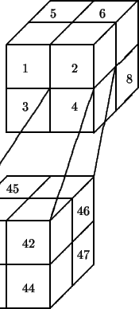[5]

Each ray that pierces the voxel is tested for intersection against the objects in this list.

5.1.2 Uniform Spatial Subdivision

In 1986, A. Fujimoto and his colleagues introduced the idea of subdividing the viewing volume into uniformly sized voxels [2]. This data structure is called SEADS (Spatially Enumerated Auxiliary Data Structure). The subdivision is completely independent of object shape and topology and thus fails to take any advantage of object coherency. A point in the viewing volume is indexed into a node directly (i.e. point (x, y, z) corresponds to node 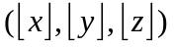. This method is similar to dividing a screen into pixels in 2D. The preprocessing costs more space and time. However, SEADS provides enough coherencies to make fast tracking algorithm possible. Paired with the data structure, Fujimoto and his colleagues suggest an efficient traversal scheme named 3D-DDA. This is an extension of DDA which is used to determine a set of pixels passed through by a line in 2D. The speed of the traversal method, in scenes with large number of objects, will (hopefully) offset the other disadvantages of the uniform space subdivision.

3D-DDA may be implemented in many ways. Here’s an approach detailed in [5].

A major difference between 3D-DDA and the DDA algorithm is that all voxels pierced by the ray must be identified, not just the nearest ones. To understand how 3D-DDA works, we will first examine the extended DDA algorithm where all pixels pierced by a line are identified.

Extended 2D-DDA Algorithm
- Let 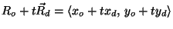denote the ray
- Let s₁=y_{d}/x_{d} denote the slope of the ray, and for simplicity assume
- The pixels are identified by their lower left hand corners, and the ray starts in pixel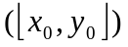
- Depending on the position of the ray's origin and the slope s₁ any of the right, diagonal, or up pixel can be pierced next by the ray
- Let e denote the ``error'' in y at the left hand edge of the current pixel, that is when , or , thus
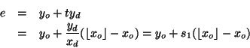

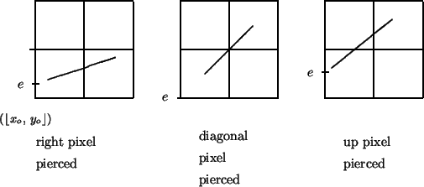
- If , the right pixel is pierced next
- If , the diagonal pixel is pierced next
- If , the up pixel is pierced next
- Every time through the loop of the 2D-DDA algorithm, the right or diagonal pixel will be identified, but a special test must be made for the up pixel

3D-DDA Algorithm
- The 3D-DDA used two synchronized 2D-DDA's working in mutually perpendicular planes
- Let s₁=y_{d}/x_{d} and s₂=z_{d}/x_{d} and suppose both these slopes are between -1 and 1
- Consider the 2D-DDA extended so every pixel hit by a ray is identified
- Assume is the ray's origin and 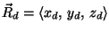is its direction
- Let s₁ = y_{d}/x_{d} denote the xy slope and s₂=z_{d}/x_{d} the xz slope, assume both are between 0 and 1
- A 2D-DDA is run in the xy plane and xz plane simultaneously; together they identify each voxel pierced
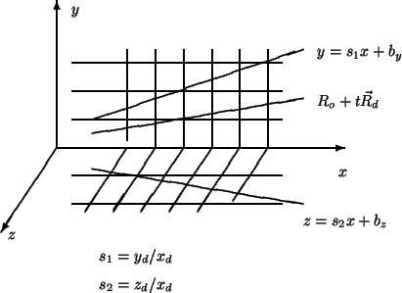[5]

3D-DDA is applied along the ray direction, and it directly identifies all three indices of the cell. Because incremental logic is inherent to 3DDDA, all intersections (with the exception of initialization) are processed without any (floating point) multiplication or division. This is a major advantage of using 3DDDA.

3D-DDA traces only the relevant extents (cuboids), and it traces them in the appropriate consecutive order. No global sorting for hidden points is necessary. Local sorting with a rather limited number of items is occasionally necessary when more than one segment is hit within a single cuboid. In general, though, the number of cells containing more than one element will tend to decrease with increasing resolution of the mesh. [2]

3D-DDA may be adapted to work with octrees. This will avoid the heavy space overhead of SEADS.

5.1.3 Binary Space Partitioning (BSP) Tree

To compute spatial relations between n polygons by brute force entails comparing every pair of polygons, and so would require O(n²). Using BSP Trees can reduce the number of operations to anywhere from O(n log₂ n) to O(1) base on scene decomposition. The reduction in number of operations occurs because Partitioning Trees provide a kind of “spatial sorting”. The idea is to represent a three dimensional space as a balanced (or, as balanced as we can get) binary tree (BSP tree). Unlike the previous two approaches, the tree is generated based on the composition of the scene. Division of the nodes need not be uniform. Each leaf of the tree contains a list of object its volume intersects. The optimal BSP tree contains just one object in each leaf. There is no leaves wasted representing empty spaces. As a result, it should require less memory than either of the previous approaches.

Several different heuristics have been formulated and applied in constructing the BSP tree. Here we will explore two approaches, one is volume oriented. The other is scene oriented.

Volume oriented approach:
- Start with a root node which represents the bounding volume containing all objects of the scene.
- Divide the volume into two by a plane. The dividing plane may be in any orientation. However, in ray tracing, it is advantageous if partitioning planes are perpendicular to space axis. This makes test which side of a plane a point lies on simpler.
- Determine which object lies in which half of the divided volume. Store this information into either the left of the right child node off the parent. Continue subdividing the volume until the given minimal number of objects per leaf is reached or the depth of the BSP reaches the given maximal value.

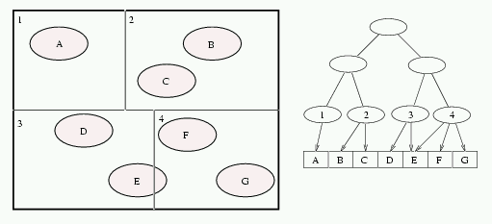
Space subdivision (left) and the corresponding BSP tree (right) [7]

Scene oriented approach
- Here, we start with a list of polygons contained in the scene. A polygon is selected and placed at the root.
- Test each remaining polygon to see which side of the plane containing the root polygon it lies in, and is placed in the appropriate side list.
- A polygon that intersects the plane containing the root polygon is split, and each of the pieces is placed in the appropriate list depending on which halfspace it lies in.
- The left and right subtrees are recursively constructed using the descendent sublists generated.
- Here is an example in 2D:
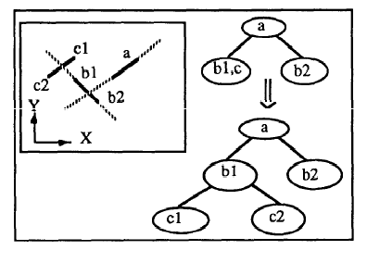 [8]

During traversing a ray, simple tests are recursively performed starting from the root of the BSP tree. Comparing distances between intersection points for the ray and node bounding box and intersection with the ray and cutting plane, one can easily decided if one or both halfspaces could be visited by the ray. A good idea is to store nodes possibly pierced by the ray into a stack. Recursion is stopped when a leaf node is reached. If all intersection tests with objects from candidate list fail, another node is pop up from a stack and recursive traversal process continues. [3]

5.2 Algorithm Analysis and Comparison

5.2.1 Potential Problems and Solutions

Octrees:

The Octree approach may generate redundancy because subdivision planes are done regardless of positions and dimensions of objects. As a result, some objects may be tested several times against a ray. Also, some objects can be referenced from many voxels. Here is a 2D quadtree division of a scene which clearly demonstrates this problem:

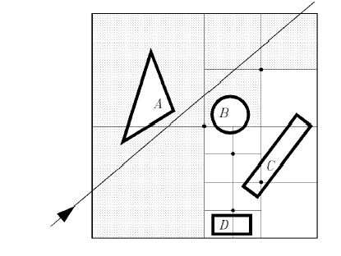[3]
Object A is tested several times. Object C is referenced by multiple voxels.

One way of avoiding unnecessary intersection test is to maintain a “mailbox” associated with each object. Each ray is tagged with a unique ID. When an object is tested for intersection, the results of the test and the ray tag are stored in the object’s mailbox. Before any additional test is done, the mailbox associated with the object is searched for the particular ray. If an earlier result exists, it is retrieved without recalculation.

If the octree is implemented with a real tree structure, there is no easy and fast way to find the voxel directly related to a certain point in the viewing volume. Also, traversing from one node to a neighboring one requires moving up and down in a tree structure. Using a hash table to tie octree voxel with the coordinates of the viewing volume may solve the above problem. This can also avoid wasting time with empty voxels.

Another serious problem with this algorithm is that it may lead to objects being erroneously missed. For example:

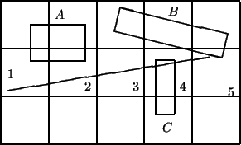 [5]

Object B is in voxel 3 and it intersects the ray. If the affirmative intersection test with this object causes the ray walking to stop at voxel 3, the intersection with object C, which is closer, will never be found.

The simplest way to solve this problem is to not terminate the propagation of a ray until it leaves the volume that contains the entire scene (i.e. at the root). Suppose we compute the distances along the ray to the points where it intersects the bounding faces in the root node. Call these distances sx, sy, sz. Then on each cycle, when dx, dy or dz is incremented, it can be tested against its limit. This adds no more than three comparisons per cycle.

Another approach to solve the problem is to continue the voxel tracking process until the nearest intersection point is contained within the current voxel.

A large amount of memory is required to keep the information in the octree structure. Meagher proofed the quantity of memory required to store a 2D quadtree object is of the order of the perimeter of the object. Similarly, the memory and processing computation for a 3D object is on the order of the surface area of the object. In addition, the octree is an approximation of a smooth surfaced object by small cuboids, so it is inevitable that the encoded object acquires some notched surfaces. In order to avoid displaying a jagged surface, the object must be represented by a very deep octree. This means the most important advantages of the octree, namely processing speed and memory economy, are lost. [2] Most implementation takes a hybrid approach and does not implement pure octree structure. In fact, in [1], the octree is not stored at all. Only the resulting hash tables after analysis are kept in memory.

SEADS
A tremendous amount of memory is needed to store SEADS. It may also waste time and resources dividing areas that are not needed (i.e. empty). Also, SEADS generates more empty cells than both the octree and the BSP tree.

The cell array contains n³ entries. To avoid redundant intersection calculations, n should be large enough that most of the entries are null. This implies that most of the space in the cell array will be wasted. [15]

A hashing scheme can be used to speed up traversal through empty voxels. Two arrays are maintained as follows:
- A full-sized array of one-bit entries to indicate whether or not each voxel is empty
- A smaller hash table which in consulted when the current voxel is not empty. [15]

SEADS also have the redundant ray-object intersection test and premature exit problem described in the octree section. The solutions described in the octree section apply here as well.

BSP Tree

A major problem of using this approach is how to choose the hyperplanes properly so that the size of the binary partition, i.e., the number of resulting fragments of the objects, is minimized. The resulting tree should be more balanced and requires less memory than an octree approach. According to [11], a collection of n arbitrarily oriented segments requires a BSP of worst-case size is 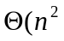) using their optimized techniques. However, it can be as high as O(n³) using a straightforward approach. In [12], another technique is presented to lower the upper bound to 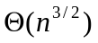 If the segments are axis-aligned.

On problems like this, it makes sense to solve it using a greedy algorithm. However, according to [8], a greedy algorithm may actually result in constructing a tree with O(n²) nodes, while there exist a tree for the same n-polygon instance with only O(n) nodes.

Good news is, empirical results first appearing in [Naylor81] indicated that partitioning tree representation of 3D polytopes resulted in trees much closer to 0(n log n). [16]

BSP Tree also requires intervention by the user to describe the scene appropriately. Anything that depends on a user could lead to human error or oversight. Furthermore, each implementation can only be optimal to certain types of scene.

BSP Tree also has the redundant ray-object intersection test and premature exit problem described in the octree section. The solutions described in the octree section apply here as well.

5.2.2 Complexity Analysis

The running time of a rendering technique is highly scene dependent. As a result, instead concentrating on certain scene, we will analyze how to predict cost per ray when a spatial subdivision acceleration technique is applied.

The running time T of a ray-shooting algorithm can be expressed as follows:

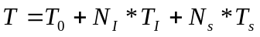 [19]

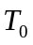 = time needed to find the cell of the starting point of the ray
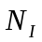= number of ray-object intersections needed to find the closest intersection
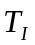 = time of a single ray-object intersection calculation
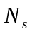= number of cells that are visited
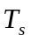 = time needed to step from one cell to the next cell.

Naïve Ray Tracer
If no spatial subdivision is used, then obviously the number of ray-object intersection is linear in the number of objects, while there is no ray traversal cost. This has the complexity of O(snm2^{k}) where n=number of objects, m=the number of pixels, k=maximal ray tree depth and s=supersampling factor. [4] For spatial subdivisions such as the SEADS, the BSP tree and the octree, the number of objects interested is greatly reduced, but ray traversal becomes more expensive.

Ideal Situation:
Global scene properties can be captured by three factors: the object count, the object size, and the object locality. Object count is used widely in theoretical complexity analysis. [10]

Assume that the number of cells in a spatial subdivision equals the number of objects N in the scene (which in practice is usually close to optimal). Further assume that the objects do not block any rays and that any tree structures are completely balanced. Finally, the size of the objects is assumed to be small with respect to the cells they occupy. Under these simplifying circumstances, an upper bound for the following spatial subdivisions may be constructed:

T_{cell} = cost for traversing a single cell
T_{int} = cost associated with a ray-object intersection test

SEADS
The number of SEADS cell is N, so that in each direction x, y, and z the number of cells is 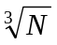. A ray will travel linearly through the structure, visiting the same number of cells on average:
T = ( T_{cell} + T_{int}) = O()

BSP Tree
For a BSP Tree with N leaf cels, the height of the tree will b e h, where 2^{h} = N. The number of cells traversed by a single ray is then O(2^{h/3}), giving:
T = 2^{h/3}(T_{cell} + T_{int}) = ( T_{cell} + T_{int}) = O()

Octree
In a balanced octree with N leaf cells, the height of the tree is h, where 8^{h}=N. A linear traversal of a ray with such an octree will intersect O(2^{h}) cells:
T = 2^{h}(T_{cell} + T_{int}) = ( T_{cell} + T_{int}) = O()

In practice, such an upper bound almost never occurs. First of all, objects have a positive surface area, which means objects can block rays. Second objects are generally not homogeneously distributed over space. An octree or BSP tree spatial subdivision will therefore not be balanced. Both assumptions account an increase in performance over O(). For this reason, a cost estimation based on a simple object count will not be very accurate. [9]

Octree Analysis:

In this section, an expression is derived which incorporates both the blocking capabilities of objects and the unequal distribution of objects over space. For a more accurate cost estimation of ray traversal, a cost function is derived based on the average tree depth.

In the average tree depth computation, large cells contribute more to the depth than small cells, because large cells stand a higher probability of being traversed than small cells. The weights are computed according to the area of a face of the cells in that level, because the surface area of a cell determines the probability that a ray will enter this cell. The weighted average tree depth 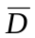 thus becomes for the octree:

=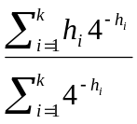
- k = the number of leaf cells in the tree
- h_{i} = the level of the i^{th} leaf cell.

The total number of cells at this depth of the octree would be 8. A ray linearly traversing through the octree would therefore on average intersect 2 cells, if it wasn’t blocked by any object.

Here we need to compute an average blocking factor which accounts for the fact that once a ray enters a leaf cell, it may intersect an object with some probability p. This probability is expressed by the ratio of the area of each object and the area of the cell it is in. To speed up this computation, the surface areas of the bounding boxes of each object in a cell my be take as an approximation.

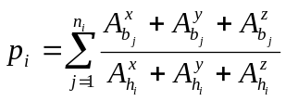

= blocking factor for leaf cell i
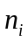= number of objects contained in cell i
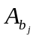= dimension of the object along x, y and z axis
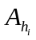= dimension of the octree cell along x, y and z axis

The blocking factor computed this way is always over-estimated because a bounding box usually has a larger surface area than the projection of the relevant object onto the bounding box. The average blocking factor can be computed by weighing the contributions of each cell according to the surface of the leaf
cells:

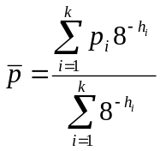

Ray Traversal Cost:

The traversal cost per ray C_{t} is affected by the weighted average blocking factor 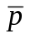and the weighted average tree depth in the following way:

C_{t} 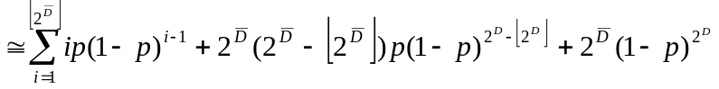
In plain words, the cost per ray C_{t} is congruent with the sum of the probabilities that this ray is blocked in the i^{th} cell pus the probability that the ray isn’t blocked by any object at all (last term). Each ray may encounter at most 2leaf cells, as it traverses linearly through the octree.

Ray-object intersections:

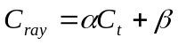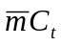
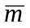= average number of objects per leaf cell
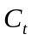= ray traversal cost
and  = algorithm and machine dependent constants. [9]

SEADS Analysis:

In this section, volume heuristics are used to estimate the cost of uniform grids. [15] The augmented volume of an object is used, which is the sum of the volumes of grid cells where the object resides.

As stated before, Cleary proposed in his paper to enhance uniform subdivision with some hashing scheme. As a result, total space requirement derived from his technique must provide for: a hash table, a bit table, and list of references to objects attached to each voxel and the description of the objects themselves. Total space required for this algorithm can be calculated as follows:

S = 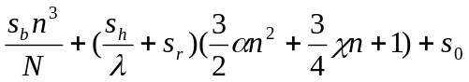 [15]
- 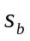 = space required for each entry in the bit table. Therefore, total space required is 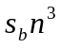.
- = load factor or fraction of non-null entries
- N = number of polygons in the scene
- 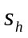= size of each entry in the hash table.
- The hash table uses 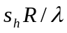 where R is the total number of references to objects in voxels. It can be derived using augmented volume as 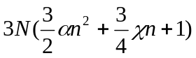
- 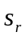= chain of references to objects intersecting a non-empty voxel. Total space required would be 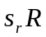
- 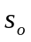= space used by each object. Total would be given by 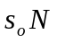
- n = number of voxels in the grid of given N objects. In most cases, n lies between 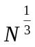and 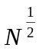.
- = mean area of objects
- 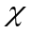 = mean circumference of objects.

The execution time per ray can be divided into three components. First, there is a constant composed of the calculations in initiating the ray and doing any processing after a successful intersection calculation (if any). The second component is doing intersection calculations whether successful or unsuccessful. The third component is the time spent moving between voxels. Here’s the equation for total time per ray:

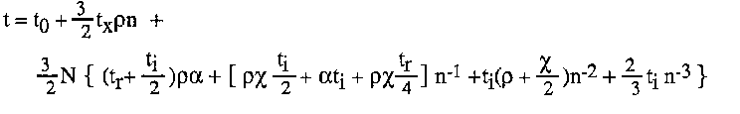
- = constant overhead for every ray
- = time taken to do a next voxel calculation. The average time taken to do a next voxel calculation is: 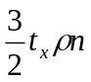
- = time to do an initial intersection calculation
- = time to do a repeated intersection check
- = mean area of objects
- = mean circumference of objects.
-  = length of an average ray
- N = Total number of objects in the scene.
- n = number of voxels in the grid given N orbjects. [15]

BSP Tree Analysis:

When a BSP tree is used to represent a subdivision of space into cubic cells, it shows no significant advantage over a direct data structure encoding of the octree. [19]

In his paper, “Constructing Good Partitioning Trees”, [16] Bruce Naylor gave an interesting analysis on decompose a scene into a partition tree. To measure the “goodness” of a tree, he constructed a cost model based on “decision probability”. The simplest characterization is that we want short paths to high probability cells (i.e. large cells), and symmetrically, we will accept long paths to low probability cells (small cells corresponding to "detail").

By using decision probabilities rather than leaf probabilities, we see that locally the best situation at internal region is one in which we have a partitioning which most of the information is in a small sub-region (a low probability region), and as little as possible is a large region. Thus, contrary to popular opinion, balanced is not optimal in general, where balanced means equal sized trees with equal probability of being selected. Balanced trees are optimal only if the data is uniformly distributed, which of course is the same distribution which uniform grids provide the optimal search structure. However, 3D geometric data is usually distributed very non-uniformly (consider a pine tree in an empty field).

Let us now construct a cost model. Consider first a single operation involving a tree T and some other operand, such as a point, a ray or another tree, referred
to as the input and denoted as I. Expected case analysis requires that one have a probability distribution of the input and the cost of performing the operation. By weighting the cost by the probability, the expected cost is defined as the weighted sum of all inputs:
E_{cost}[ T, I ] = 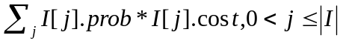 [16]

Now to compute the expected cost for a particular operation for a given tree T, we will in effect insert I, treated as a random variable, into the tree. To do this we need, as always, to know how to "partition" I at an internal region r, and in this case this means we need to know the probability of I lying in r+ and r-. If we assign a unit cost to the partitioning operation then we have:
E_{cost}[ T, I ] =
IF T is a cell
THEN 0
ELSE 1 + p- * E_{cost} [T⁻] + p+ * E_{cost}[T⁺] [16]

6.0 Conclusion:
One very important point that does emerge is that, in many cases, the irreducible overhead of any ray tracing algorithm (initializing the ray, doing lighting calculations etc) is a large fraction of the total execution time – usually more than 50%. This implies that dramatic gains cannot be expected from incremental improvements to ray tracing itself. [15]

Now, given that, how does spatial coherence approach measure up to other acceleration techniques? How about to a straight forward conventional ray tracer?

6.1 Comparing To a Naïve Ray Tracer:
A naive ray tracer has two major drawbacks. They are:
- Rays are checked against all objects.
- Rays are checked against objects even though they may be distant from it.

The spatial coherence approach overcomes both of these major contributions to overheads. The regions resulted from a 3D subdivision scheme are processed in order along the ray from its origin. The first object encountered by the ray is the first hit.

6.2 Comparing To Bounding Volumes and Bounding Volume Trees:

The bounding volume acceleration technique is highly scene dependent. Its efficiency is almost entirely dependent on how well the object fills the space of the bounding volume. Each ray must still be tested against the bounding extent of every object and the search time becomes a function of scene complexity. Major savings can be achieved by using a hierarchical structure (i.e. a tree) of bounding volumes. However, a hierarchical description may be difficult or impossible based on the nature and disposition of objects in the scene. At any rate, the resulting hierarchy and bounding volume are, again, highly scene dependent and cannot apply to general cases. The major innovation of the special coherence methods is to make rendering time constant and independent of scene complexity. This is especially apparent in the case of Uniform Spatial Subdivision where all occupied space is divided into equally-sized voxels regardless of occupancy by objects.

6.3 Comparing to Each Other:
A SEADS subdivision obviously generates many more voxels than the octree subdivision. It thus involves ‘unnecessary’ demands for storage space. However, uniform subdivision is still favored over subdivision adapted to a scene construction such as in a BSP tree. In 1986, Fujimoto stated in his paper that the method of uniform space division is faster than adaptive space division. [3] This observation was reiterated by Cleary in 1988 [15]. Both methods rely on tracing a ray’s path through a sequence of empty voxels until a non-empty voxel is encountered. In the adaptive schemes, the voxels are of unequal size, which makes the cost of traversing empty voxels relatively high. In the case of uniform division, the cost of skipping empty voxels is very low, but there are more to be skipped. However, the optimum levels of space division are surprisingly small. It is usually sufficient to divide the world space into a few hundred voxels. Another advantage of uniform subdivision is that it does not require knowledge of how to group objects efficiently. This often requires intervention by the user to describe the scene appropriately which may not achieve an optimal solution and cannot be used to apply to general cases.

In conclusion, the Octree approach is good for scenes whose occupancy density varies widely. Unfortunately, this can lead to extremely unbalanced tree. Traversal through an octree often takes longer than the other two approaches. SEADS is accompanied by a fast traversal scheme. However, it has the fatal flaw of massive and unavoidable memory overhead. A carefully constructed BSP tree is smaller than an octree for most scenes because the tree is balanced. Memory cost and void areas are smaller than an octree.

7.0 Ray Tracer Implementation

Yvonne Lu has developed an elementary ray tracer. The only acceleration technique implemented is the bounding box method. Although the ray tracer ran 50% faster when using bounding box, the picture came out fuzzy. There may be a bug in the program. Anyway, here are some interesting pictures from our ray tracer:

The Application looks like the following:

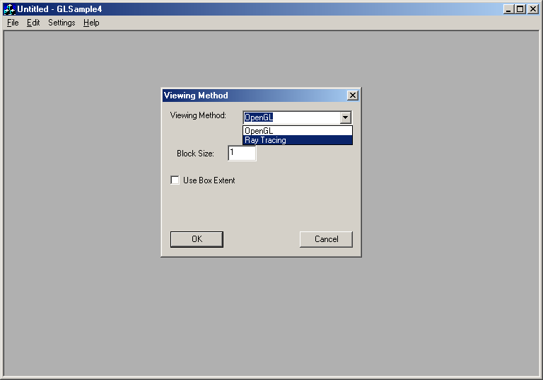

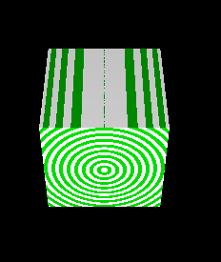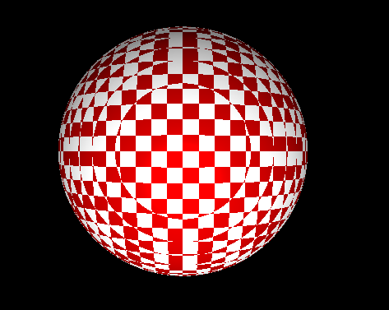

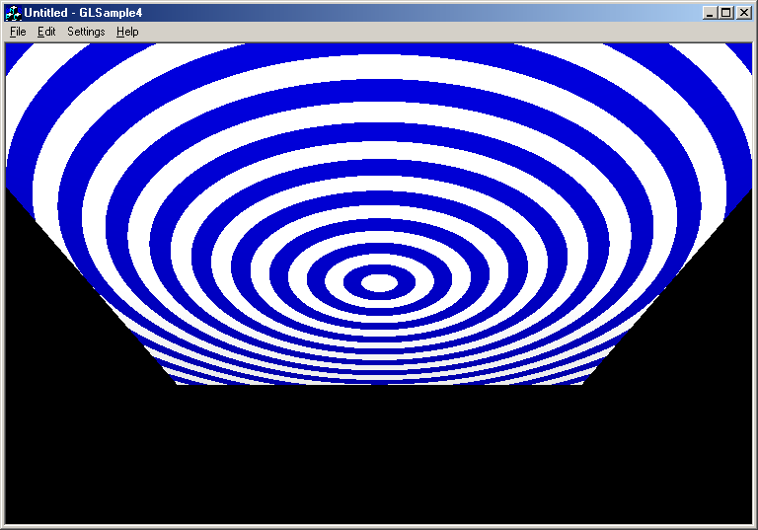
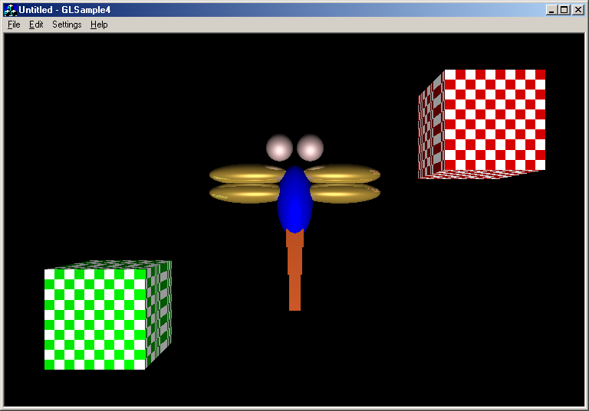
Without the Bounding Box

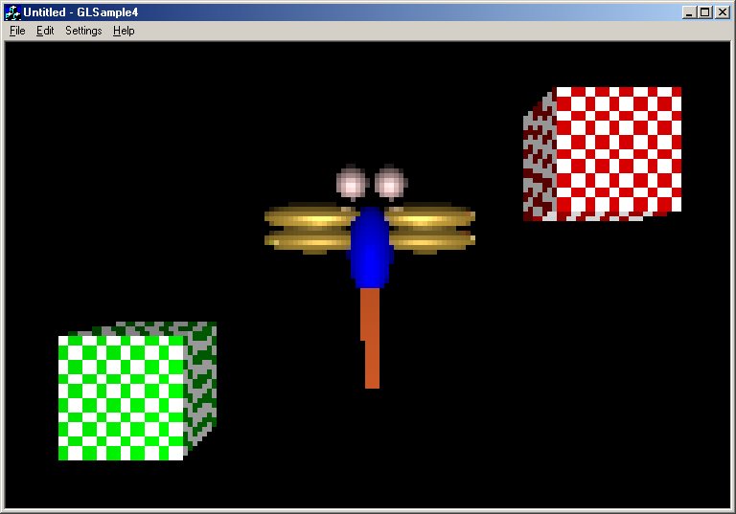
With Bounding Box

References
  - S. Glassner: “Space Subdivision for Fast Ray Tracing”, IEEE CG&A, pp. 15-22, October 1984.

  - “ARTS: Accelerated Ray-Tracing System” by Akira Fujimoto, Takayuki Tanaka, and Kansei Iwata” Graphica Computer Corporation, IEEE CG&A pp 16-26 1986

  - “Speeding up Ray Tracing – SW and HW approaches” by Jiri Zara In: Proceedings of 11th Spring Conference on Computer Graphics - SSCG 95. Bratislava : Dom techniky, 1995, p. 1-16. ISBN 80-233-0344-9.

  - “The Challenge of Ray Tracing” by Dr. Ann M. McNamra, Trinity College, Dublin – http://www.cs.tcd.ie/courses/baict/bass/4ict10/Hillary2003/pdf/Lecture17_6Mar.pdf

- “Recursive Ray Tracing” by William Shoaff - http://www.cs.fit.edu/wds/classes/adv-graphics/raytrace/raytrace.html

- “A Tutorial on Binary Space Partitioning Trees” by Bruce F. Naylor, Spatial Labs Inc. - http://www-2.cs.cmu.edu/afs/andrew/scs/cs/15-463/pub/www/notes/bsp_tutorial.pdf

- “Ray Tracing with BSP and Rope Trees” by Jaroslav Køivánek, Vojtìch Bubník, Departement of Computer Science and Engineering , Czech Technical University, Faculty of Electrical Engineering, Prague, Czech Republic

- “On Constructing Binary Space Partitioning Trees”, Ravinder Krishnaswamy , Ghasem S. Alijani , Shyh-Chang Su, Proceedings of the 1990 ACM annual conference on Cooperation January 1990

- “Cost Prediction in Ray Tracing” by Erik Reinhard, Arjan J.F.Kok, Frederik W. Jansen In Rendering Techniques '96, pages 41--50. Springer-Verlag, June 1996.

- “Cost Prediction for Ray Shooting” by Boris Aronov, Hervé Brönnimann, Allen Y. Chang, Yi-Jen Chiang In: Proceedings of the eighteenth annual symposium on Computational geometry, 2002 , Barcelona, Spain, Pages: 293 – 302,ISBN:1-58113-504-1

- “Efficient binary space partitions for hidden-surface removal and solid modeling” by Michael S. Paterosn and F. Frances Yao, Discrete Cornput. Geom., 5:485-503, 1990.

- “Optimal Binary Space Partitions for orthogonal objects” by Michael S. Paterson and F. Frances Yao, In: Proceedings of the first annual ACM-SIAM symposium on Discrete algorithms, 1990, ISBN = 0-89871-251-3, p100-106, Society for Industrial and Applied Mathematics

- “Volume Rendering” by Mark Meyer , CalTech, http://www.gg.caltech.edu/~cs174ta/Winter/Lectures/lecture9.pdf

- “Adding Special to Effects” by Charles Goldsmith, The Wall Street Journal, Feb 26, 2003

- Cleary, John G., and Geoff Wyvill. ``Analysis of an Algorithm for Fast Ray Tracing Using Uniform Space Subdivision.'' , The Visual Computer, Vol. 4, 1988, p. 65-83.

- B. Naylor. “Constructing good partitioning trees.” In Proceedings of Graphics Interface '93, pages 181{191, Toronto, Ontario, may 1993. Canadian Information Processing Society.

- Advanced Animation and Rendering Techniques Theory and Practice by Alan Watt and Mark Watt, Addison-Wesley 1992

- Kaplan, M.R., “Space Tracing, a Constant Time Ray Tracer”, SIGGRAPH’85 Tutorial, San Francisco, July 1985

- “On the Efficiency of Ray-shooting Acceleration Schemes” by László Szirmay-Kalos and Vlastimil Havran and Benedek Balázs and László Szécsi, Proceedings of the 18th spring conference on Computer graphics, 2002, ISBN=1-58113-608-0, p97-106, ACM Press

- J. Kajiya, “The Rendering Equation”, SIGGRAPH 1986, Dallas, TX, U.S.A., August 18-22, Volume 20, Number 4, 1986, pages 143 – 149

- Turner Whitted, “An Improved Illumination Model for Shaded Display”, ACM, June 1980, Volume 23, Number 6, pages 343 – 349

- Steven Rubin and Turner Whitted, “A Three-Dimensional Representation for Fast Rendering of Complex Scenes”, SIGGRAPH 1980, Computer Graphics, August 1980, Volume 20, Number 4, pages 143 - 150

- Eric A. Haines and Donald P. Greenberg, “The Light Buffer: A Shadow-Testing Accelerator”, IEEE Computer Graphics and Applications, September 1986

- CS426, Princeton University, http://www.cs.princeton.edu/courses/archive/fall00/cs426/lectures/raycast2/sld008.htm

